**My Cab Buddy Screen And Description**

**Login Page:**

A registered user login into the application to book a cab for himself/herself.

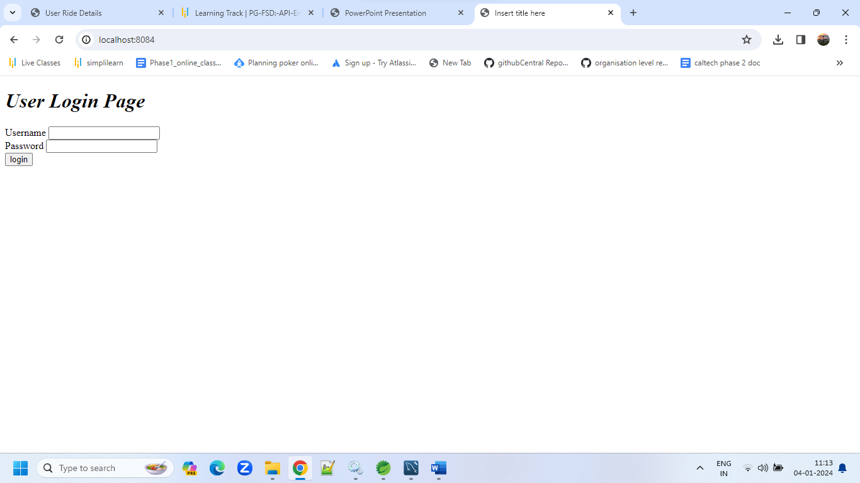

Once the user has logged in succefully,he has a welcome page with an option given to book a new ride

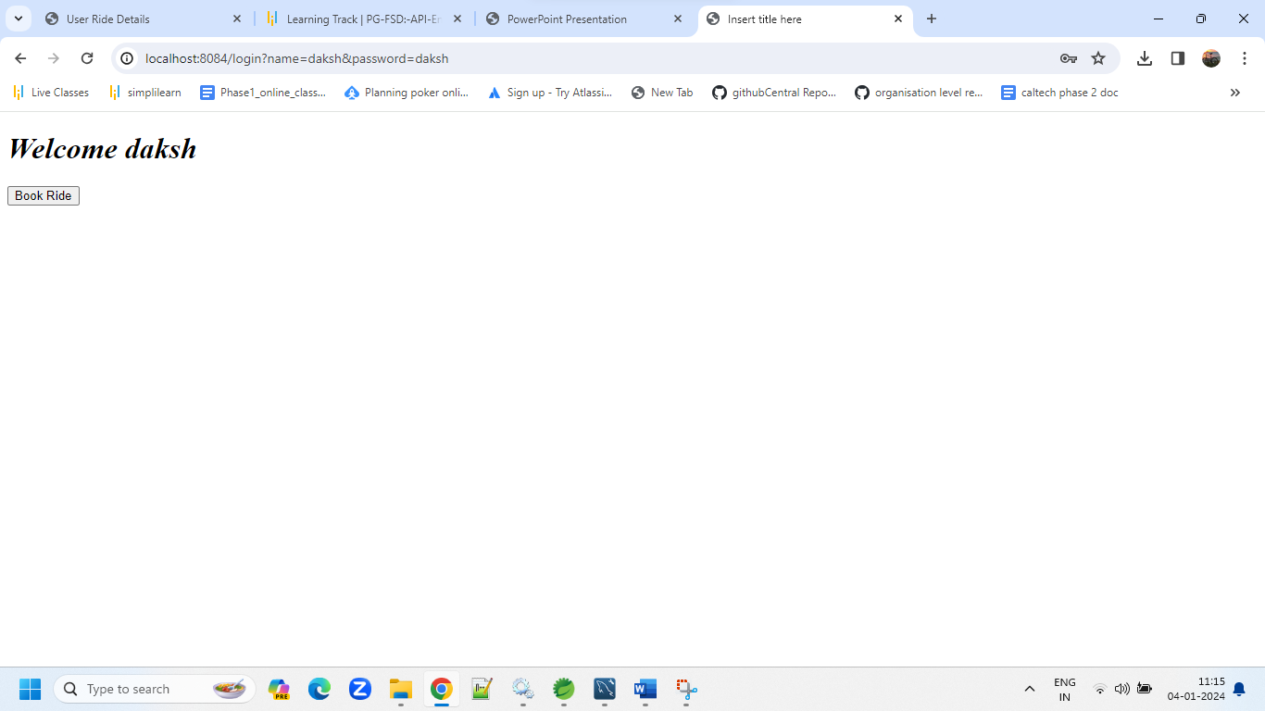

Once he clicks on Boom ride button ,the book a ride page appears

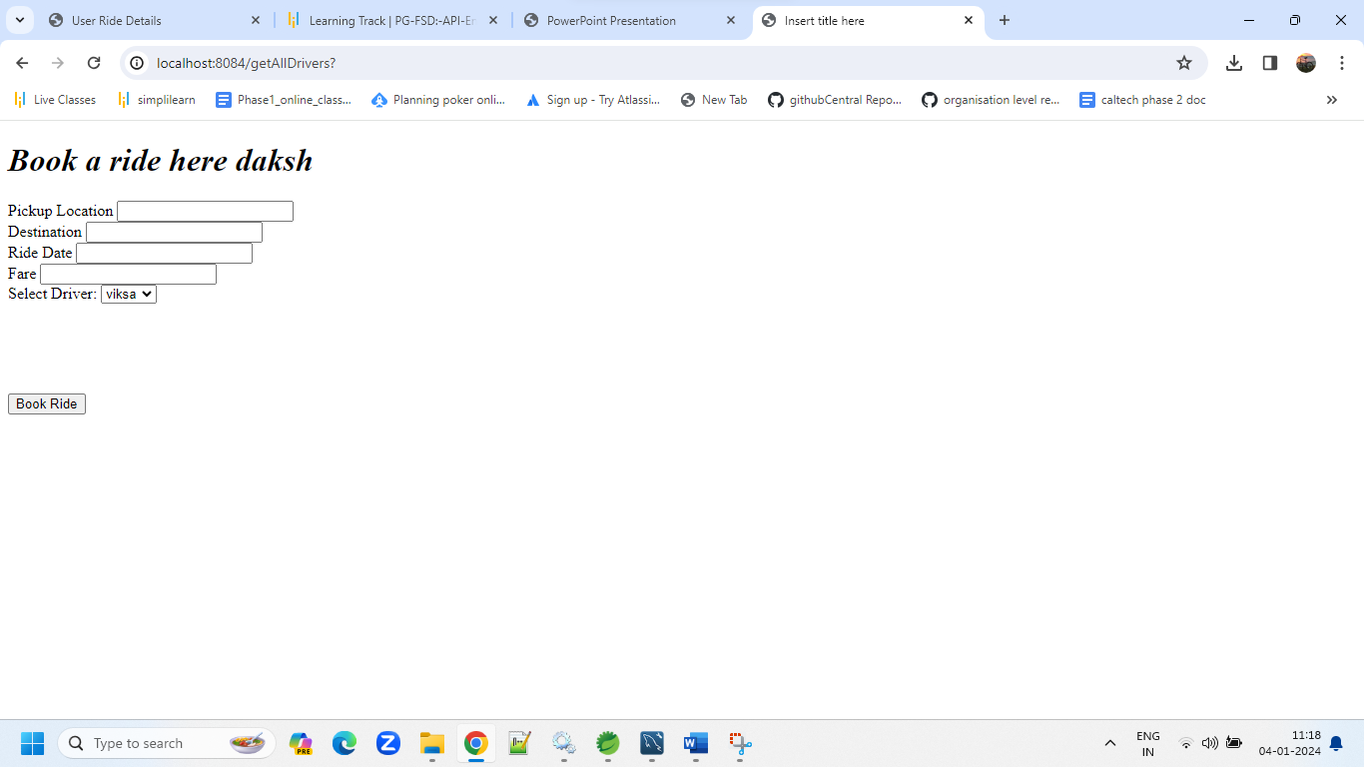

Once the ride is Booked the success notification page appears with an option to see all the previous rides.

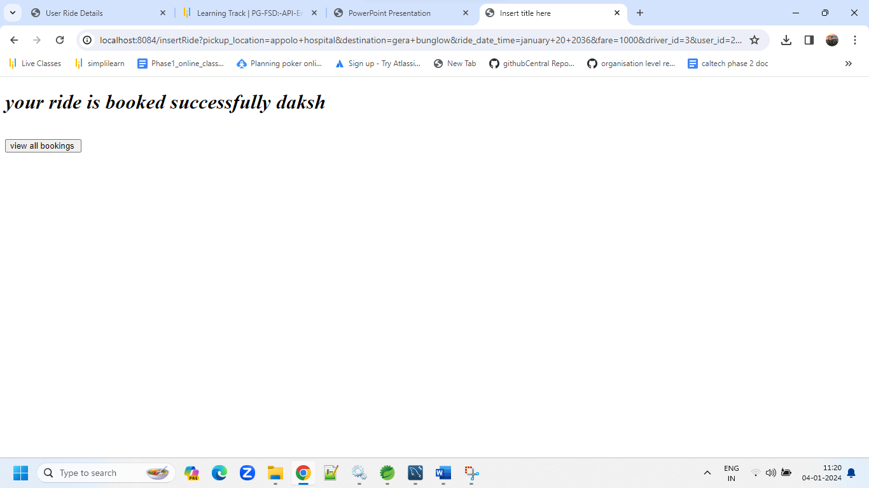

The user can see all his previous bookings with driver details ,dates and timings

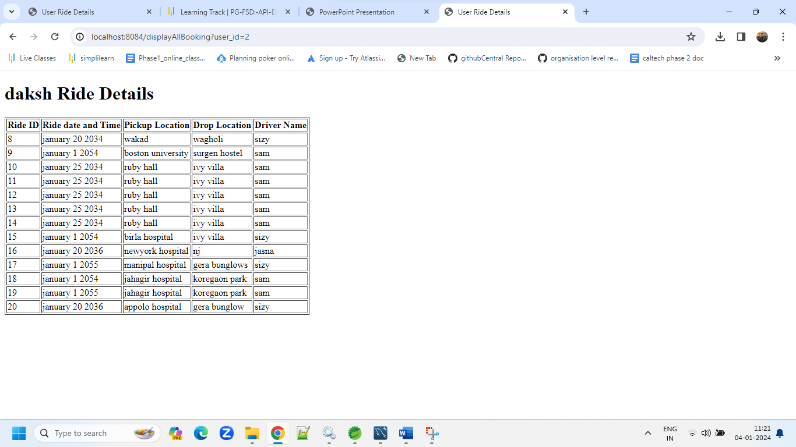

For a first time user ,he/she can register herself/himself before booking any ride

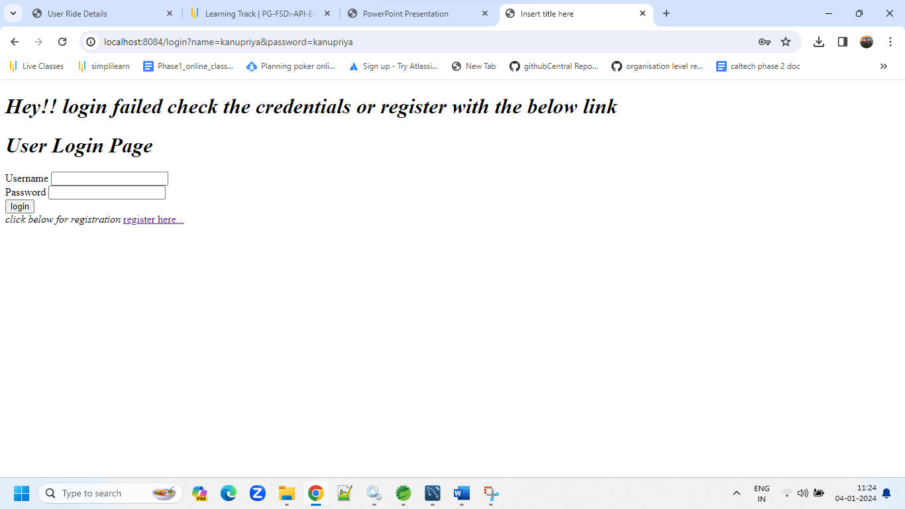

Registration Page

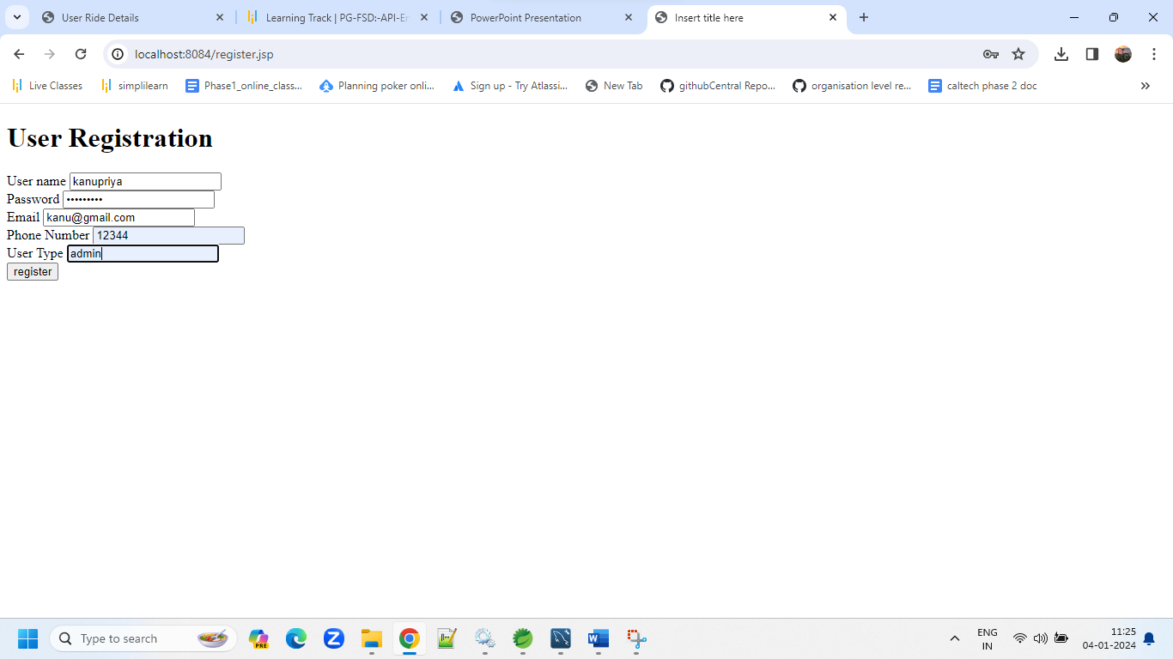

**Registration success page**

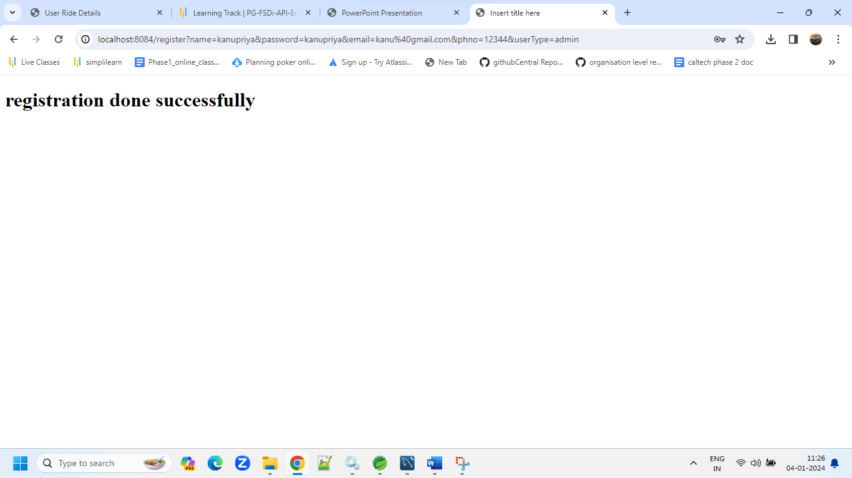

**The data Populated via Postman**

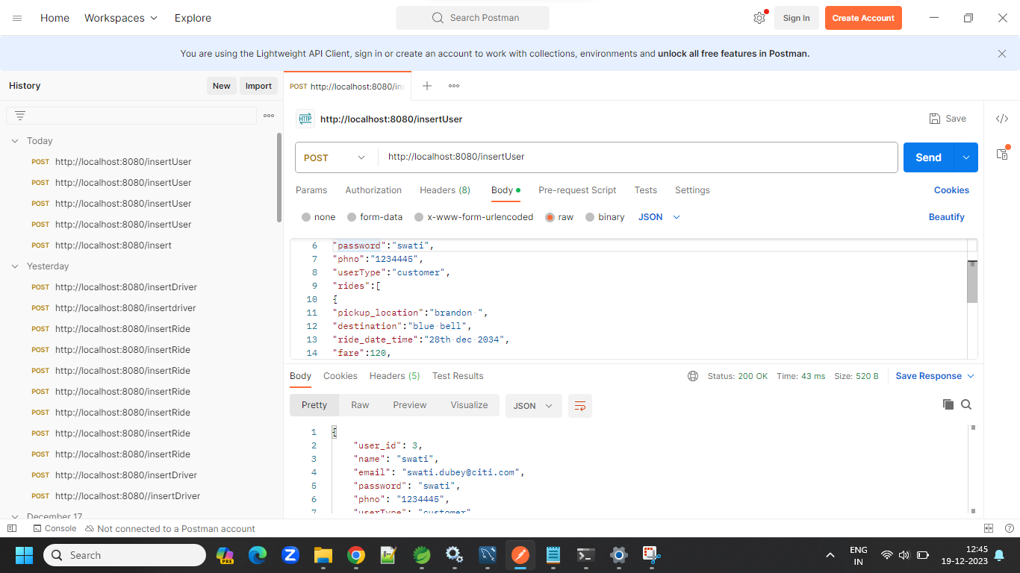

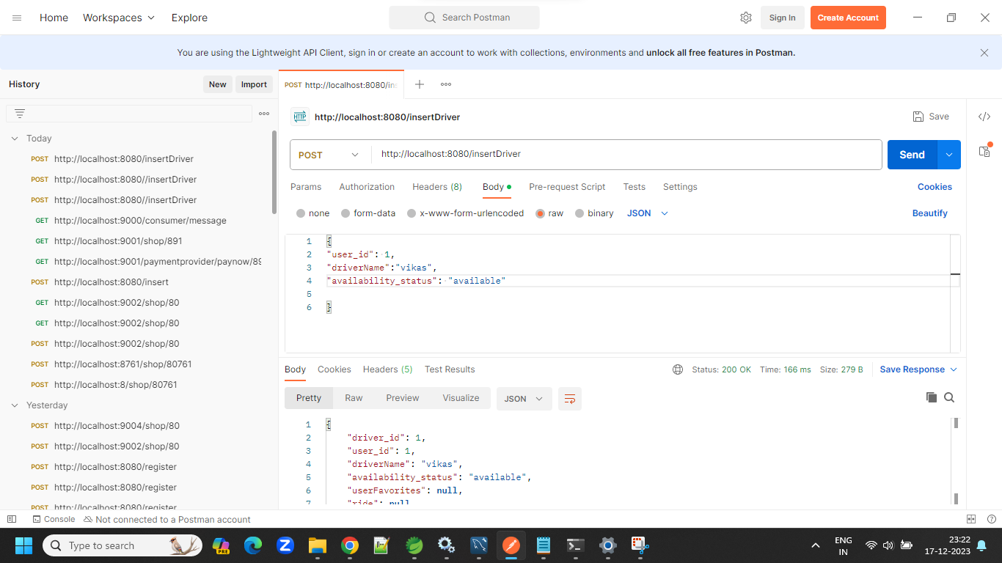

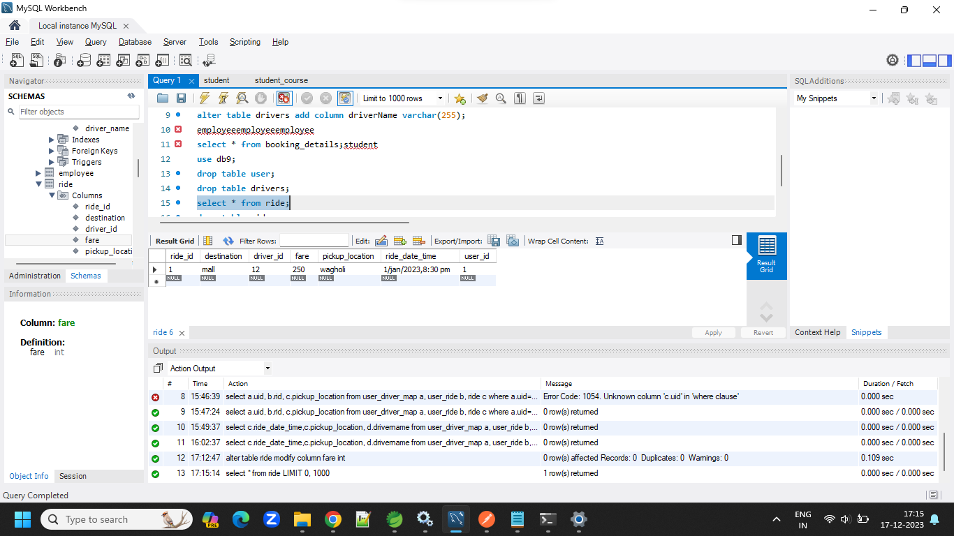

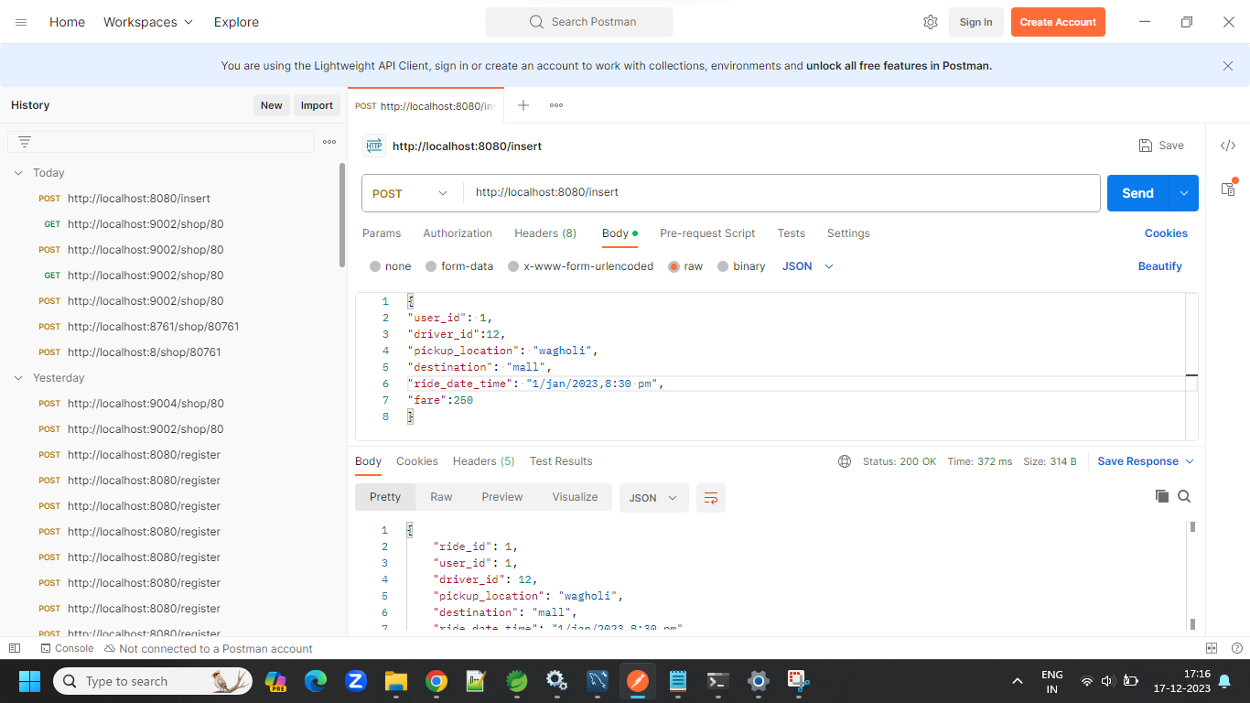

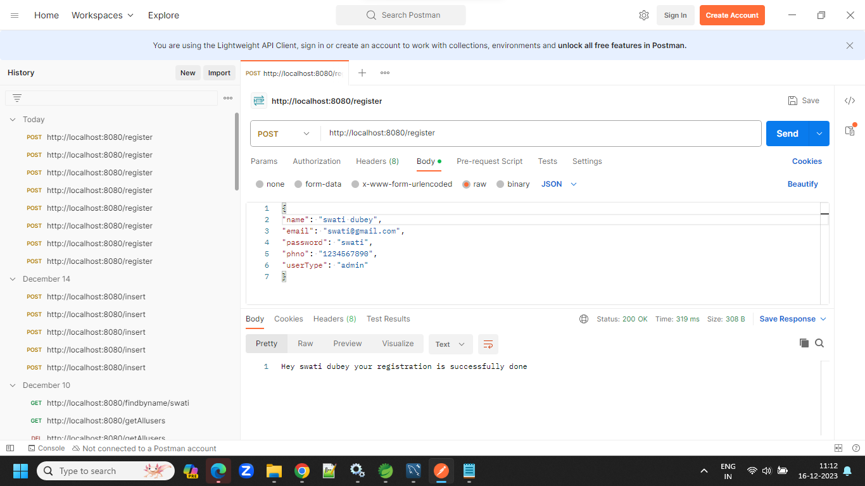

**Junit Test**

